Ideation Phase
Empathize & Discover
Date | 04 October 2026
Team ID | SWTID-2026-6870
Project Name | Streamlining IT Procurement: Automating Standard Laptop Orders with Flow Designer
Maximum Marks | 4 Marks

Empathy Map Canvas
An empathy map captures what users say, think, do and feel. It helped the team understand the people affected by the manual laptop procurement process before designing the automated flow.
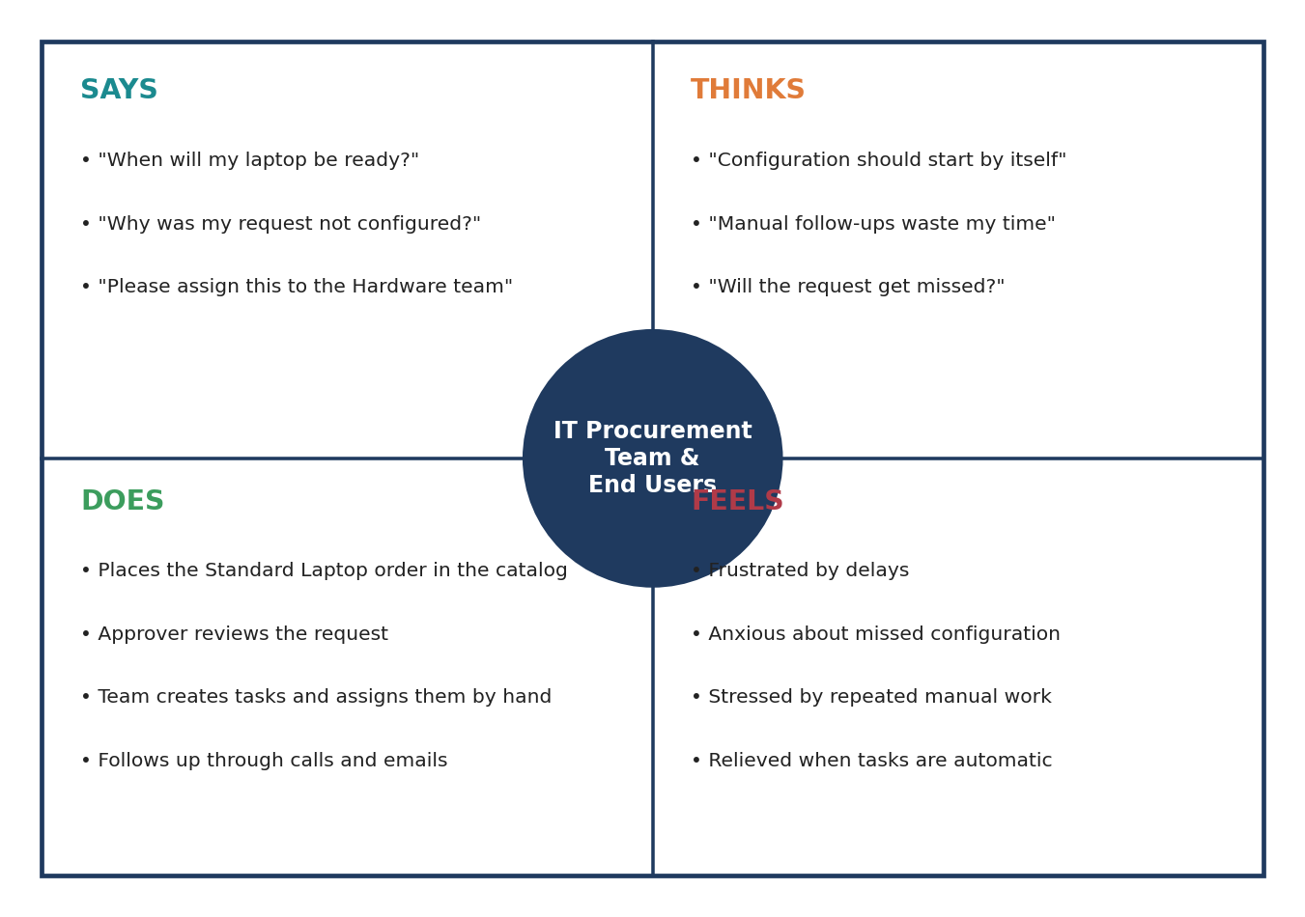
Figure 1: Empathy map – IT procurement team and end users

Pains and gains
Pains | Gains
Configuration task is forgotten or delayed  Manual creation and assignment effort  No visibility of configuration progress  Repeated follow-up calls and emails | Task is created automatically after the order  Task goes straight to the Hardware team  Requester can see the task under the request item  Less manual work and fewer errors

Insights
- Users care most about speed and certainty: they want to know the laptop will be configured without chasing anyone.
- The Hardware team needs a task that already contains the right description and assignment group.
- Automating the hand-off between approval and configuration removes the biggest source of delay.

